Forecast 3 (8+4) – Commentary
Weyland group, financial year 2026
Marcus Bell · 18 September 2026

Headline
Forecast 3 combines actuals for January to August with an updated outlook for September to December. Full-year revenue is forecast at EUR 330.5 m (-1.0 % vs. budget) and EBITDA at EUR 151.9 m (-2.6 %). Compared with Forecast 2 (6+6), EBITDA improves by EUR 1.2 m.
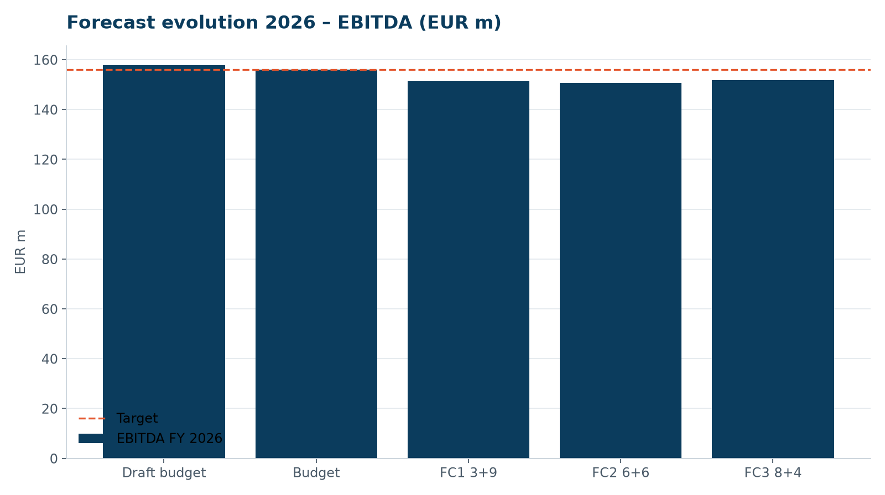
EBITDA forecast evolution, budget line at EUR 156 m

Bridge budget → Forecast 3 (EBITDA, EUR m)
Driver | EUR m
Budget 2026 | 156.0
Kestrel Ridge T-07 outage (KR-INC-2026-003), net of warranty | -1.4
Wind resource Q1 and June below P50 | -3.9
Lower forward prices Q4 (DE –3 %, GB –4 %) | -1.1
Battery trading and solar ahead of plan | +1.6
O&M savings Highline Wind Services renegotiation | +0.9
Personnel – delayed hiring | +0.6
Other | -0.8
Forecast 3 | 151.9

Risks and opportunities
- Q4 wind: each 5 % deviation from P50 moves EBITDA by around EUR 2.3 m.
- HB-RISK-017 has no P&L impact in 2026 – Harrow Bay costs are capitalised; contingency release of EUR 14.5 m approved on 6 August.
- REGO prices in the UK remain volatile (± EUR 0.4 m).
- Insurance recovery for T-07 crane costs (EUR 0.21 m) not included.

Next steps
- Review with Jonas Richter on 21 September
- Presentation to the Supervisory Board on 24 September
- Budget 2027 kick-off with cost centre owners on 1 October

